resQwest Wordpress Plugin Manual

Contents

Overview 2

Installation 2

Step 1 2

Step 2 2

Step 3 3

Embedded Easy API 4

Enabling 4

Routes 4

Shortcode 4

Automatic wordpress page creation 6

Configuration 6

Page creation 7

Images 9

Booking process flow 9

# Overview

The resQwest Easy Api Wordpress Plugin is designed to make integrating resQwest and wordpress easy.

We have also added functionality to auto create and update pages into wordpress from resQwest

# Installation

## Step 1

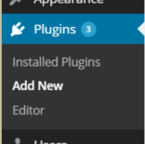Select the “Add New” menu option under Plugins in the left panel of the wordpress administration screen. On the “Install Plugins” page that appears, you will see a link titled “Upload”. Click this.

## Step 2

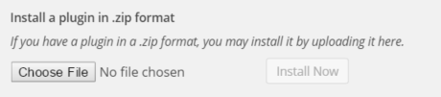

Click on the “Choose File” button and browse to where you have downloaded the “resQwest.zip” file.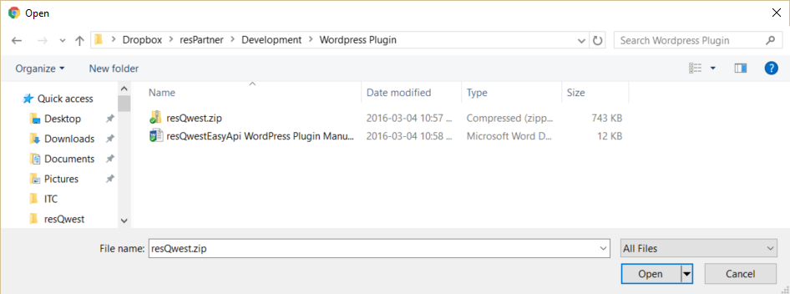

Please choose and open that file.



## Step 3

Then click the “Install Now” button to install the plugin. The plugin will install and then please click the “Activate Plugin” link.

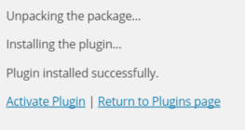

The plugin should now have successfully activated.



# Embedded Easy API

The resQwest Embedded Easy API offers the ability to embed bookability directly within a wordpress page or post.

## Enabling

When you edit a page or post you will see a resQwest configuration box near the bottom of the edit screen.

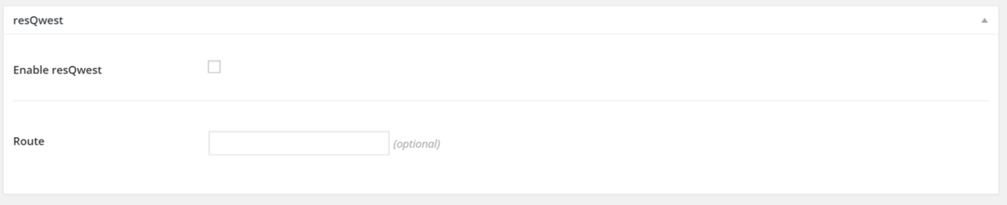

The “enable resQwest” allows you to enable the resQwest Easy Api within this page.

## Routes

The additional “Route” setting allows you to specify if a specific Category or Activity should be loaded. Leaving this blank will cause the default view for your website to be loaded, likely an all categories view.

## Shortcode

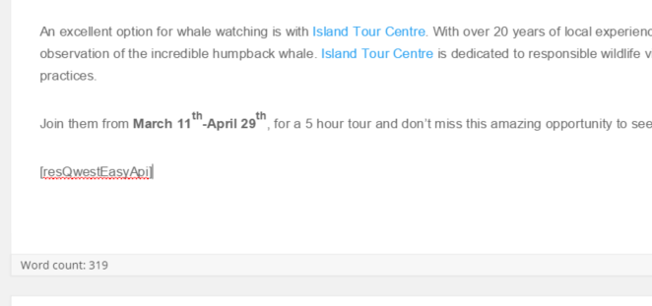

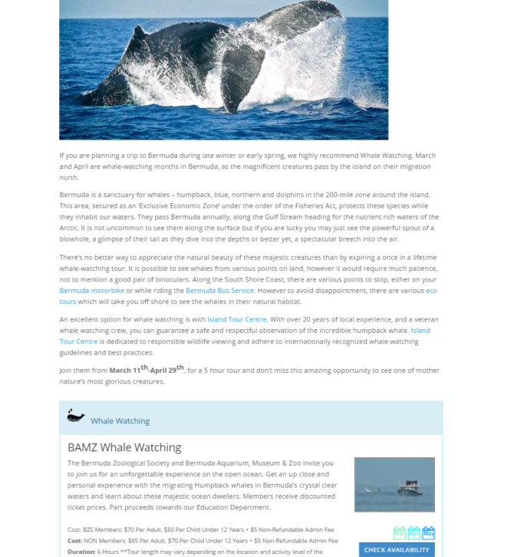If you’d like the API to appear within a specifc area of the page’s content you can add a wordpress “ShortCode” of [resQwestEasyApi] to designate where you’d like the api to be loaded.

This enables the Easy Api to be loaded within the page in the location you specify.

# Automatic wordpress page creation

## Configuration

In the resQwest settings configuration page there are two checkbox settings that can be turned on

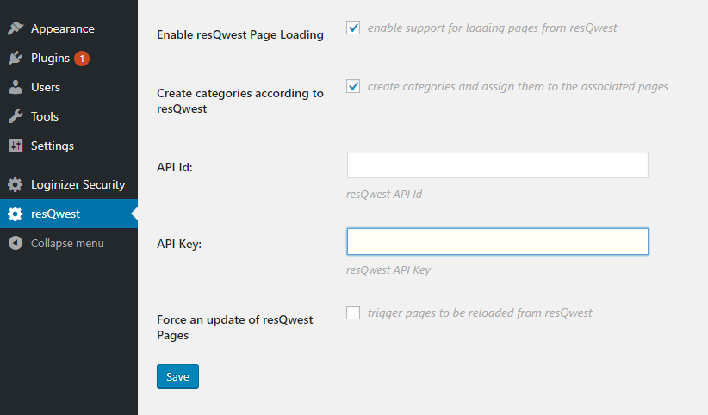

#### Enable resQwest Page Loading

This setting turns on the loading of pages from resQwest. Pages will be loaded as draft and will need to be published before going live.

The updates are set to occur regularly

#### Create categories according to resQwest

This will trigger the creation of category pages that will load the appropriate route for the resQwest category in accordance with the configuration settings in resQwest.

#### Force an update of resQwest pages

This will trigger pages to be loaded from resQwest. You can check this, click save and it will pull the associated details from resQwest immediately rather than on a timer.

## Page creation

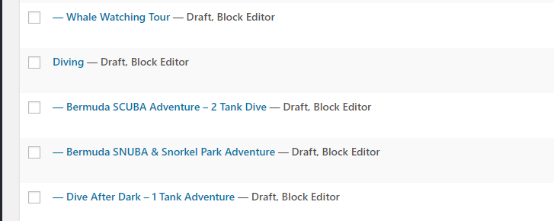

Pages will be automatically created by the plugin in accordance with settings in resQwest which trigger which inventory and categories are to appear on the website.

For example, a Whale Watching Tour configured under the diving category will be created as follows

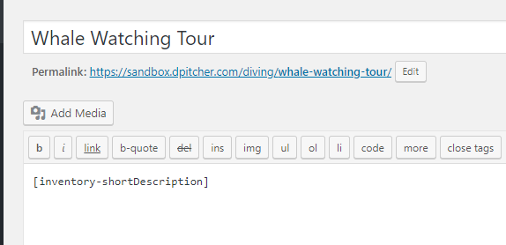

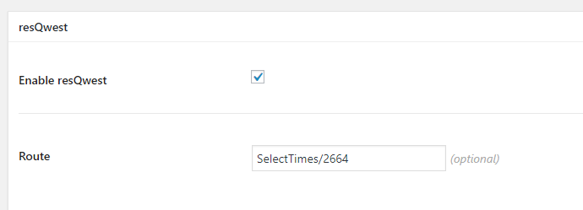

The route will be automatically set

The [inventory-shortDescription] short code is populated into the body of the page which corresponds to page meta tag values which are populated by the plugin

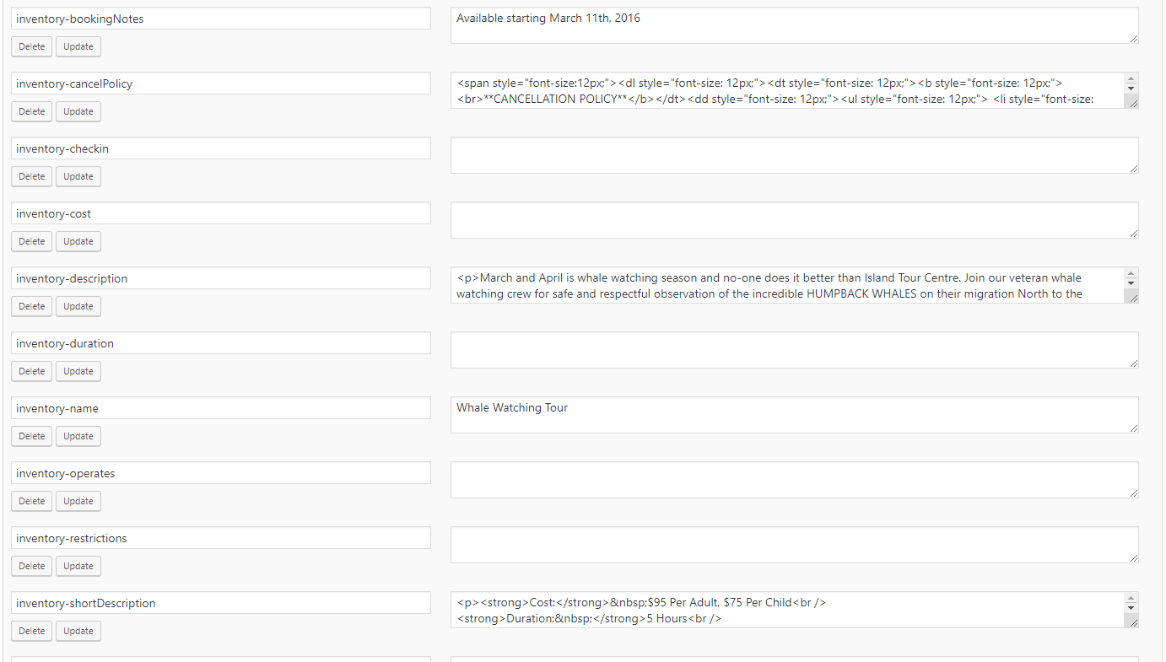

Any of these meta tag values can be referenced using a corresponding short code by wrapping the meta name with square brackets.

This allows flexibility in setting the layout of the details within the page.

The positioning of the associated inventoryselection portion of the process can still be controlled with a [resQwestEasyApi] shortcode

## Images

At this time, images are not imported by the plugin and need to be loaded manually for each page that is created.

## Booking process flow

Assuming the following page configuration

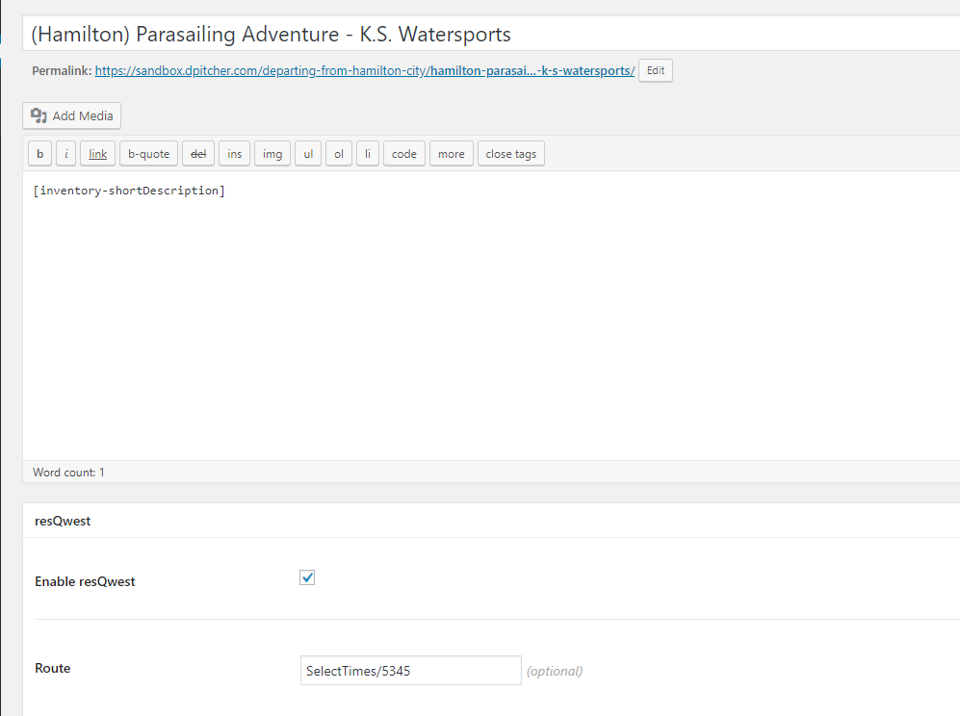

The flow of the booking process is that when an individual visits a page they will see the relevant

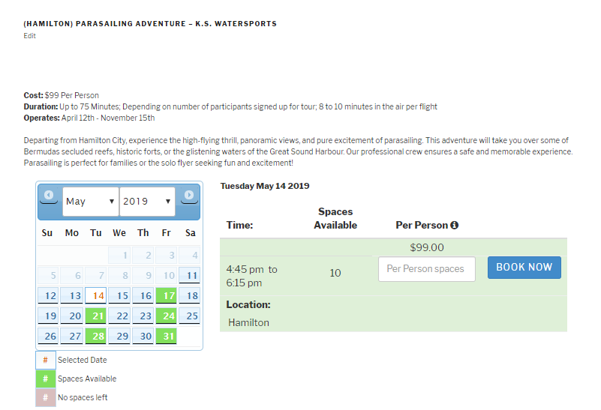

Upon selecting spaces and then clicking upon book now, the page will be redirected to the main reservation process configured within resQwest.

